# Introduction

The City of Toronto has a population of approximately 2.7 million people. It is the provincial capital of Ontario and the most populous city in Canada. Toronto is an international centre of business, finance, arts, and culture, and is recognized as one of the most multicultural and cosmopolitan cities in the world. The latest demographics show that Toronto consists of approximately 52% visible minorities.

As part of this project, we would like to analyze and visualize the neighborhoods and locations of Toronto that have the most coffee shops.

# Data Sources

For this project we need the following data:

List of neighbourhoods and postal codes in Toronto: <https://en.wikipedia.org/wiki/List_of_postal_codes_of_Canada:_M>

List of postal codes and latitude longtitude coordinates:

<https://cocl.us/Geospatial_data>

List of coffee shops restaurants in each neighbourhood in Toronto:

Foursquare API

# Methodology

For this project, a list of neighborhoods for Toronto was obtained from the Wikipedia page. The dataset included the postal codes as well as the Boroughs and each neighborhood associated with it. Any Borough that was not assigned was removed from the dataset. The dataset consisted of 103 total neighborhoods. This dataframe can be called our Neighborhood dataframe.

Following that, the geospatial data was obtained from cocl.us. The dataset consisted of postal codes for the Toronto area, as well as the associated Latitude and Longitude coordinates. The coordinate dataset was merged with the Neighborhood dataframe so that we now have Latitude and Longitude coordinates for each Neighborhood.

Now that we have the Neighborhood along with coordinates, we can obtain a list of nearby venues for each neighborhood. We do this using the GET request to the Foursquare API. A limit of 100 venues and a radius of 2000 meters was set for each neighborhood. The list returned a total of 2128 venues for all the neighborhoods.

The venue list was filtered to venues which belonged to the Coffee Shop venue category. The count was reduced to 176 total coffee shops.

Using the groupby function, we were able to obtain the number of coffee shops for each neighborhood and reduced the dataframe to only include the top 20 results.

# Results

Based on the results of the data analysis, we can see the following visualization for coffee shops sorted by neighborhood:

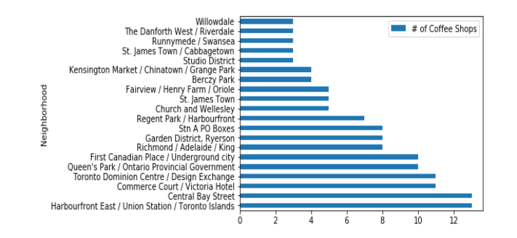

We can see that Harbourfront East / Union Station / Toronto Islands offers 13 coffee shops. Central Bay Street also offers 13 coffee shops.

# Conclusion

For the problem at hand, the neighborhood(s) in Toronto which contain the most coffee shops are Harbourfront East / Union Station / Toronto Islands, and Central Bay Street, each with 13.